CHAPTER 11: **ENTITY-RELATIONSHIP MODELLING**

**What is it about?**

* ER model is used to show the C*onceptual* schema of an organisation.
* Independent of specific data model or DBMS
* The model is later transformed into a *Logical* model (e.g. relational) on which the physical database is built
* The most widely used form of *Semantic modelling*: attempt to capitalise on knowledge of *meaning* of data to inform the model

**Perspective of the Entity Relationship Model**

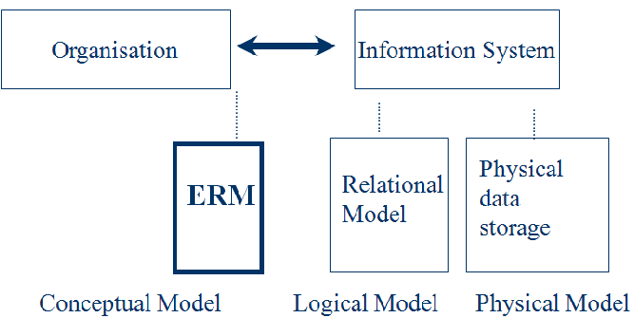

**Concepts of the ER Model**

* + The basics of Entity-Relationship modelling
    - Entities
    - Relationships
    - Attributes

**Entity Type**

* Entity - distinguishable “thing” in the real world
  + Strong (or regular) entity - entities have an independent existence (e.g. staff)
  + Weak entity - existence dependent on some other entity (e.g. next of kin)

**ER diagram of Staff and Branch entity types**

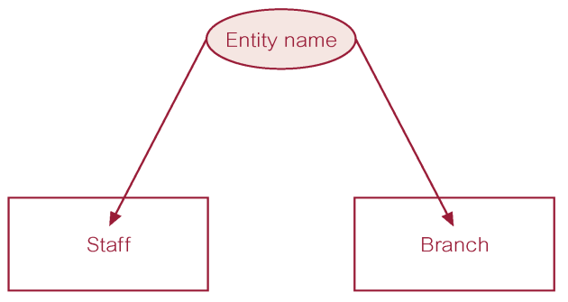

**Attributes**

* Entity types have *Attributes* (or properties) which associate each entity with a value from a *domain* of values for that attribute
* Attributes can be
  + **simple (atomic)** e.g. Surname; date of birth
    - Attribute composed of a single component with an independent existence
  + **composite** e.g. address (street, town, postcode)
    - Attribute composed of multiple components, each with an independent existence.
  + **single-valued**
    - Attribute that holds a single value for each occurrence of an entity type.
  + **multi-valued** e.g. phone number
    - Attribute that holds multiple values for each occurrence of an entity type.
  + **derived** e.g. D.O.B. ; age
    - Attribute that represents a value that is derivable from value of a related attribute, or set of attributes, not necessarily in the same entity type.
  + Relationship types can also have attributes! (see later)

**Relationship**

* A relationship is   
  “... An association among entities (the participants)...”
* Relationships link entities with each other

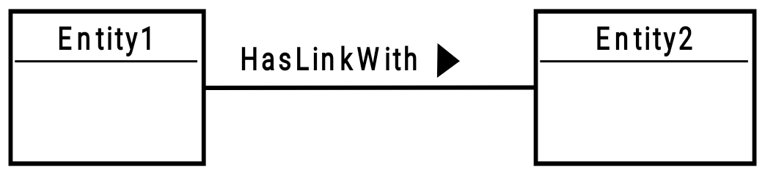

Name: verb, capital start letter, arrow indicates direction in which verb makes sense

**Types**

* Relationship type
  + Set of meaningful associations among entity types.
  + Relationship occurrence
  + Uniquely identifiable association, which includes one occurrence from each participating entity type.

**Semantic net of *Has* relationship type**

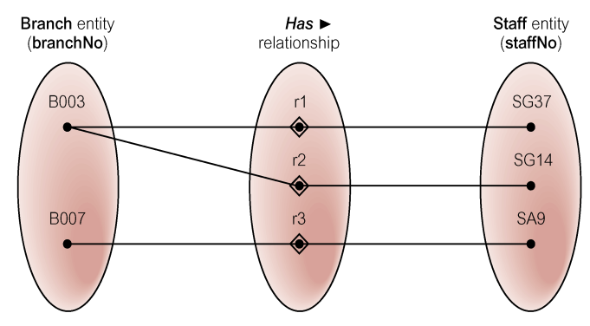

**ER diagram of Branch *Has* Staff relationship**

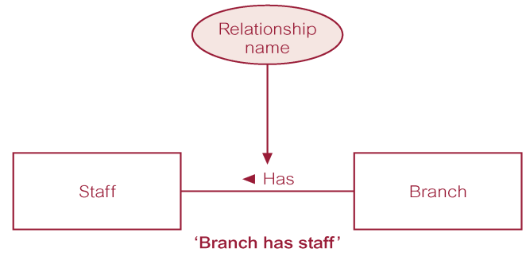

**Relationship Types**

* Degree of a Relationship
  + Number of participating entities in relationship.
  + Relationship of degree :
  + two is binary
  + three is ternary
  + four is quaternary.

**Binary relationship**

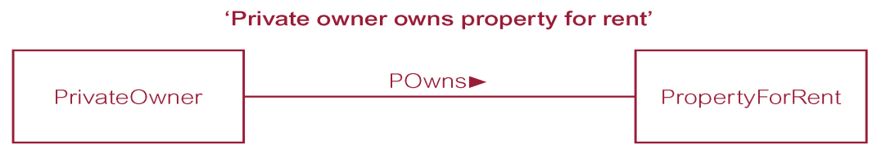

**Ternary relationship**

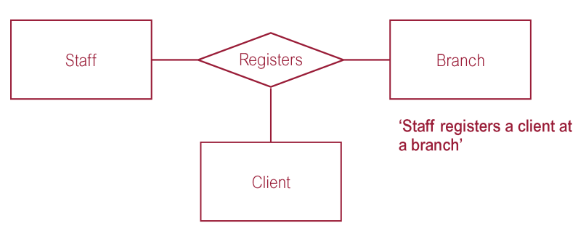

**Quaternary relationship**

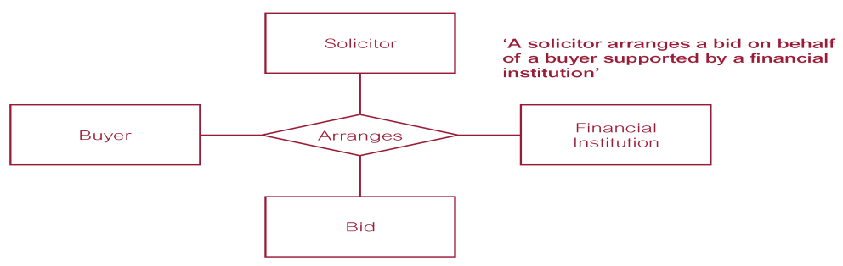

**Relationship Types**

* Recursive Relationship
  + Relationship type where *same* entity type participates more than once in *different roles*.
  + Relationships may be given role names to indicate purpose that each participating entity type plays in a relationship.

**Recursive relationship called *Supervises* with role names**

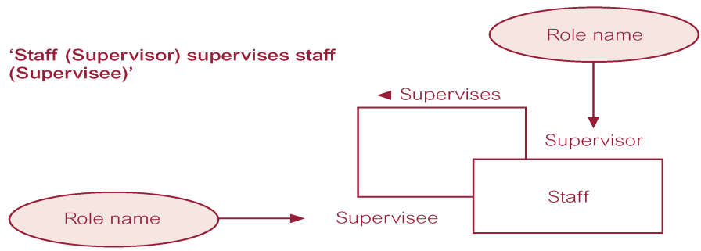

**Entities associated through two distinct relationships with role names**

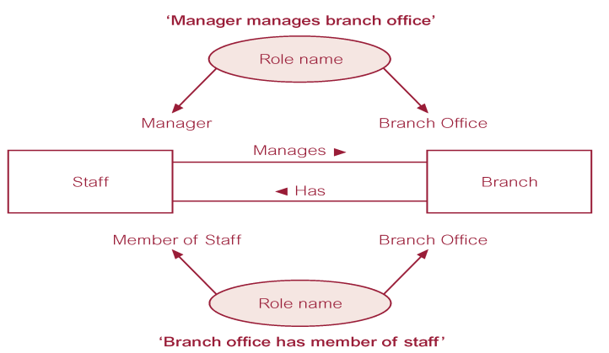

**Keys**

* Candidate Key
  + Minimal set of attributes that uniquely identifies each occurrence of an entity type.
  + Primary Key
  + Candidate key selected to uniquely identify each occurrence of an entity type.
  + Composite Key
  + A candidate key that consists of two or more attributes.

**ER diagram of Staff and Branch entities and their attributes**

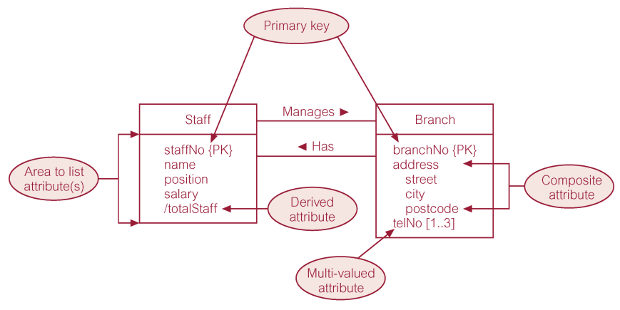

**Entity Type**

* Strong Entity Type
  + Entity type that is *not* existence-dependent on some other entity type.
* Weak Entity Type
  + Entity type that is existence-dependent on some other entity type.

**Strong entity type called Client and weak entity type called Preference**

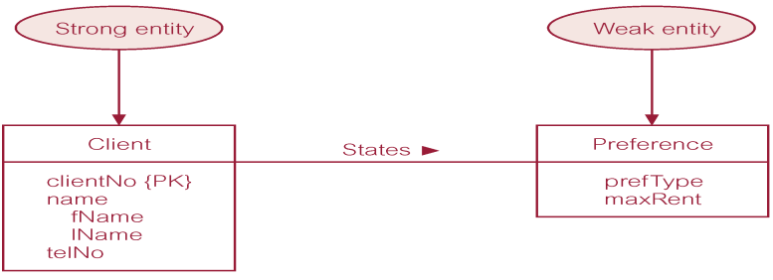

**Relationship called *Advertises* with attributes**

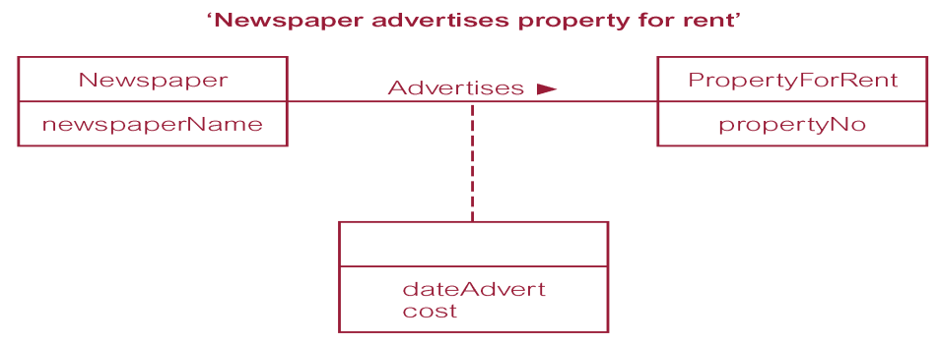

**Structural Constraints**

* The most common degree for relationships is binary.
* Binary relationships are generally referred to as being:
  + one-to-one (1:1)
  + one-to-many (1:*)
  + many-to-many (*:*)

**Multiplicity of Ternary *Registers* Relationship**

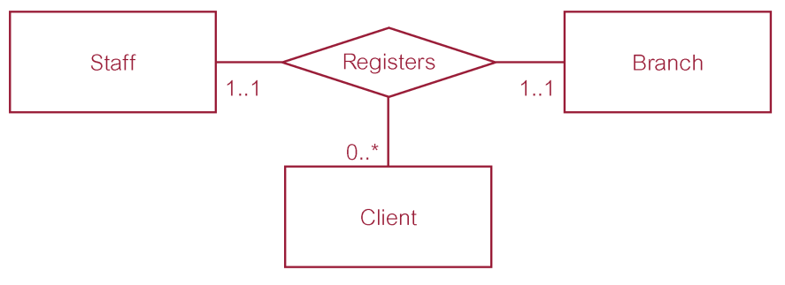

**Summary of Multiplicity Constraints**

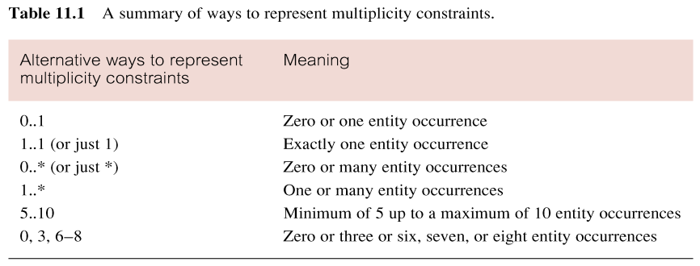

**Structural Constraints**

* Multiplicity is made up of two types of restrictions on relationships: cardinality and participation.
* Cardinality
  + Describes maximum number of possible relationship occurrences for an entity participating in a given relationship type.
* Participation
  + Determines whether all or only some entity occurrences participate in a relationship.

**Multiplicity as Cardinality and Participation Constraints**

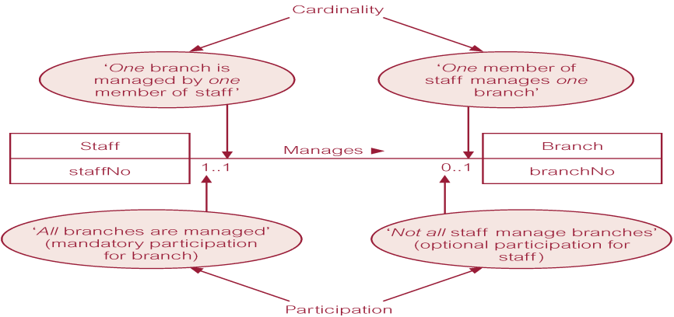

**ER Diagram of Branch View of *DreamHome***

